**FirstLook Demo Proposal for UC Plenary**

Web application is called DigitalGlobe FirstLook. It shows a world map of all the FirstLook feeds that represent the event/disaster. <http://www.digitalglobe.com/firstlook-coverage>

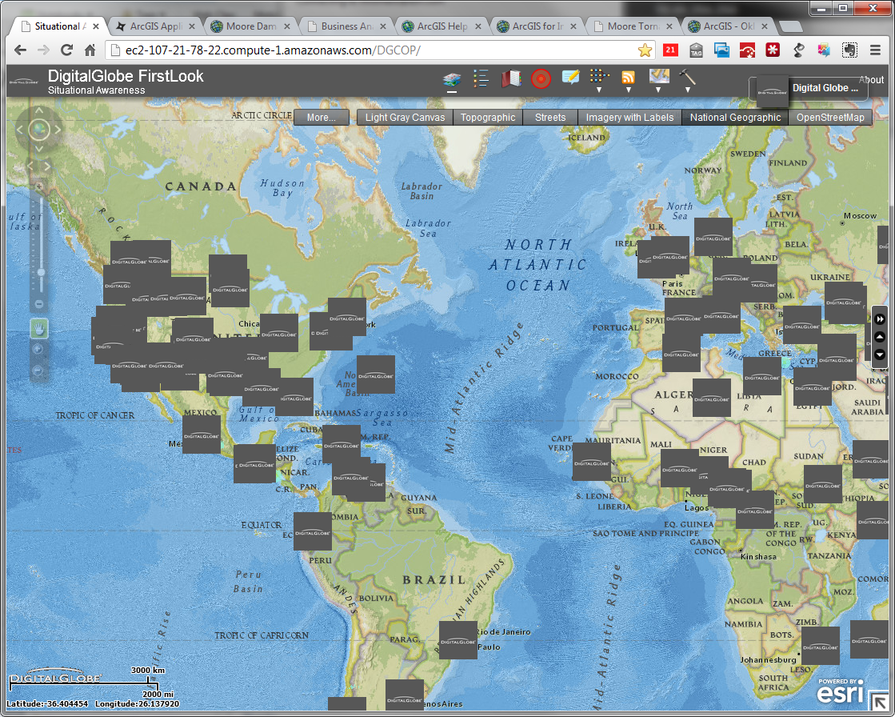

The feature is interactive and displays the popup describing the event:

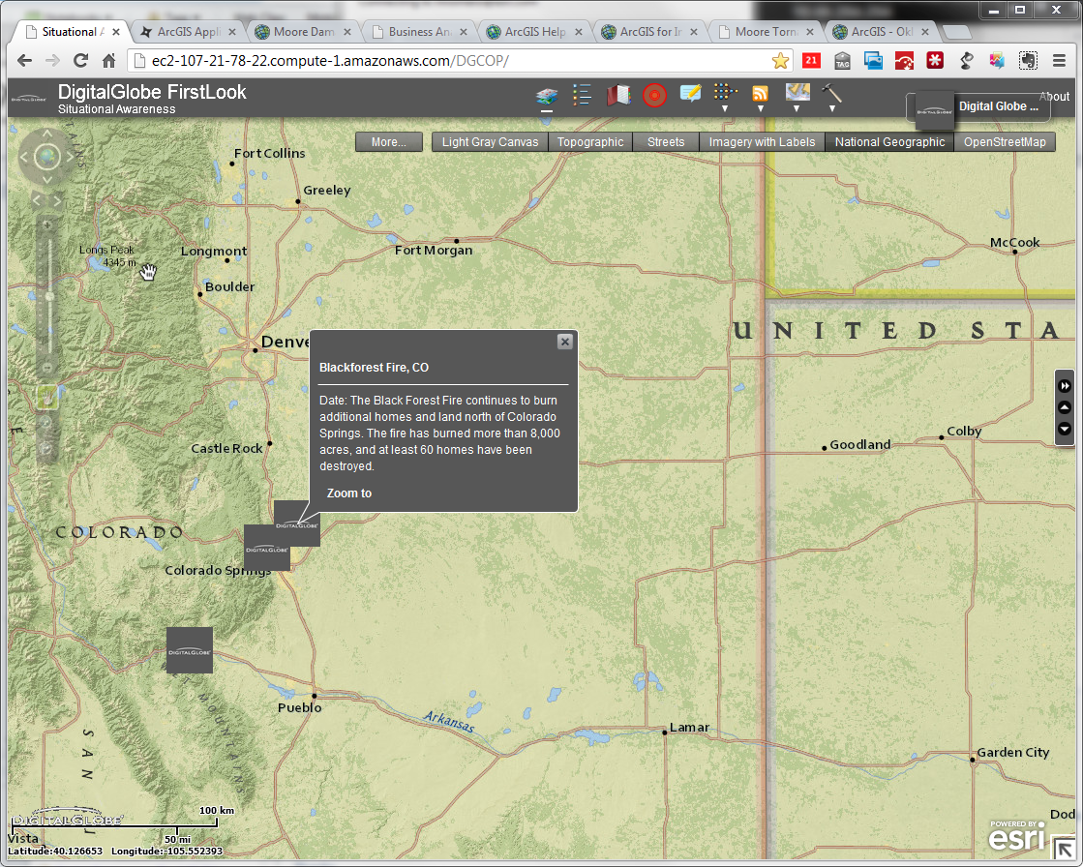

The app has some simple spatial query tools that access the Geoenrichment Premium service. For any given disaster, the user can find valuable information about the people, places and businesses in a specific area or within a certain distance or drive time from a location.

A first responder can immediately get information about what the next steps are based on

1. Where the damage is from FirstLook

2. What’s there and who’s affected from Geoenrichment

**Moore, Oklahoma**

On the ground, NGOs have to prioritize debris removal and clean up. Priority is based on the hardest hit sections of the tornado as well as homes with no insurance. Using the image service, we can visually identify where damage is, draw a polygon to perform a spatial query, and returning that information. We know it’s more accurate than a simple polygon, because of the apportionment behind the scenes.

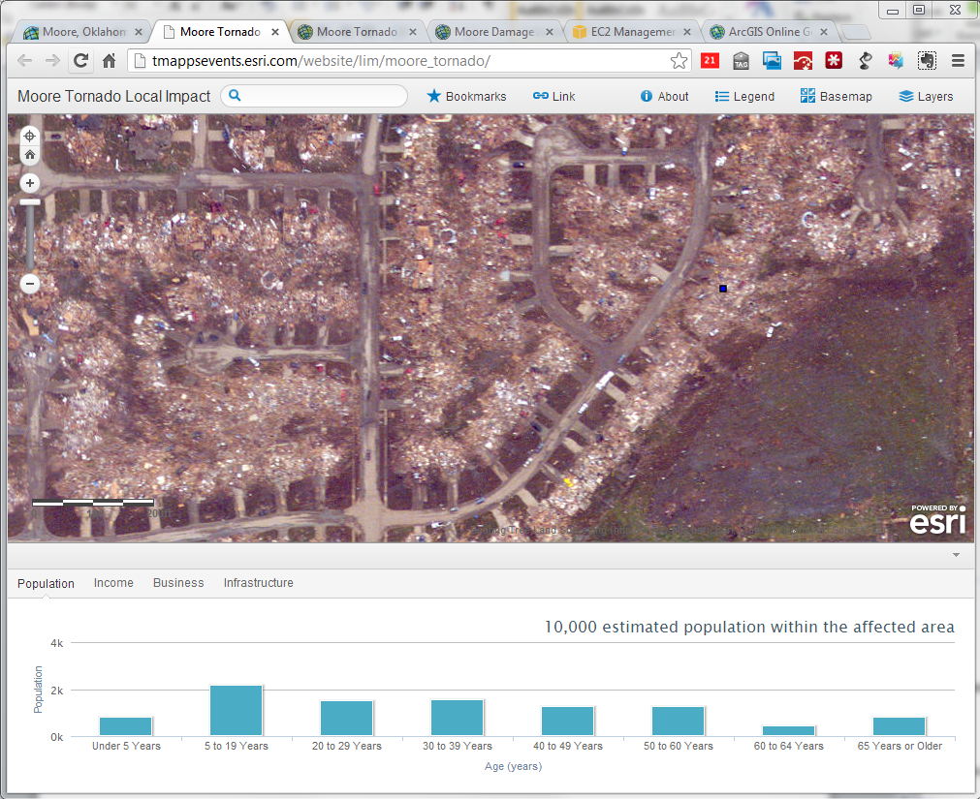

The search returns needed demographic information. Hazus can help us map the critical infrastructure, like a mall or school that isn’t damaged. This location can be used as a staging area for first responders, cleanup equipment, etc.

**Web Application Requirement**

* Functionality
  + Popup for the FirstLook GeoRSS feed
  + ~~Drawing tools to run the spatial query~~
  + Graph/Reporting Window the returns the query
  + Other UI: (very similar to Local Impact Map)
    - Title bar
    - Search window
    - Legend
    - Basemap
    - Layers
* Operational Layers in the Map
  + [Post Event FirstLook Imagery](http://disasterresponse.maps.arcgis.com/home/item.html?id=bafb8fde610447de867843c2119fb955)
  + [Building Damage from FEMA](http://fema-services2.esri.com/arcgis/rest/services/2013_OKC_Tornado/Building_level_damage_assessments_from_aerial_survey/MapServer/0)
  + Critical Infrastructure from Hazus (Get from Melanie Harlow)
* Information from Geoenrichment API to be returned
  + Property Values
  + Key USFacts
  + Age
  + HouseholdByIncome
  + Wealth
  + Policy
  + Population Demographics (age)